Expanding
Community Health Centers:
An Area of Bipartisan Agreement

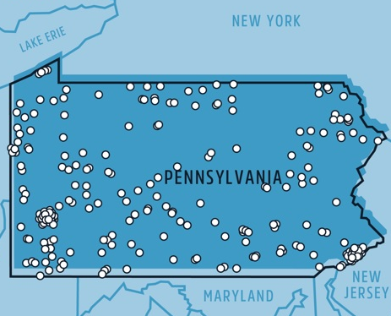

Information to Aid Effectiveness
Report for Pennsylvania

from the Consistent Life Network

September, 2022

Introduction

While debates about aspects of health reform have raged for years and are likely to continue to do so for years to come, the robust operation of Federally-Qualified Community Health Centers (CHCs) is one aspect that both Democrats and Republicans do agree on.

For Pennsylvania, the Community-Based Health Care Act of May 21, 2013 (P.L. 32, No. 10Cl.35) provides for a Community-Based Health Care Program, which includes establishing new CHCs among its tasks.

Of the many methods for finding the areas of greatest need, we offer the criterion of specific health centers that offer very limited services and have no CHCs within five miles. Since the CHCs usually offer far more comprehensive services, this is a method for identifying underserved areas.

For many Republicans, this will have the additional selling point that the specific health centers we list are operated by Planned Parenthood, adding more substance to the need to ensure that such areas become no longer medically under-served; they would prefer that services come from the CHCs instead, in the knowledge that CHCs usually offer a wider range of services.

Many Democrats will find it useful that there is this extra selling point for many Republicans, making it much easier to pass any funding bills for creation of new CHCs for more comprehensive medical coverage in these along with other areas.

Planned Parenthood has 23 locations in Pennsylvania. Of those, seven don’t have a CHC within five miles, an another has one almost five miles away and over the border in New Jersey.

Below we list each of these centers and how close the nearest CHC is to it. We have also done a web search for possible affordable and/or gynecological health facilities for two reasons:

1) these may be suitable for providing the needed medical care, so that the area is in fact not underserved, but have not gone through the process of establishing themselves as CHCs;

2) if they are apprised of the advantages and extra resources available for becoming federally qualified CHCs, this may be the speediest method of expanding health care access in that area.

The list started with all PP centers that have no CHC within 5 miles; the PP center was removed from the list when we found a Rural Health Clinic located within five miles.

There are, of course, many additional criteria that can be used to ascertain areas most in need of new CHCs. This information is intended to aid in strengthening a bill to expand access. That bill will include information from many other sources as well.

Contact: media@consistent-life.org
Lead Author: Rachel M. MacNair, Ph.D.
Voice and text: 816-753-2057
Sources

Note: The Consistent Life Network is a non-profit, non-partisan, non-sectarian organization with no formal or informal association with Planned Parenthood of America or any of its centers, nor with any Community Health Center. All information was obtained through publically-available records on the World Wide Web.

Planned Parenthood

Information on Planned Parenthood health centers was found on PP’s official website, https://www.plannedparenthood.org/health-center/pa.

Federally-Qualified Community Health Centers

Information on Community Health Centers was found at the Health Resources and Services Administration Data Warehouse “Find a Health Center” site at https://findahealthcenter.hrsa.gov/. The page has a feature allowing entry of any address, which then provides information on all CHCs within five miles; this is the reason the five-mile radius was selected as the criterion for distance. When there are none within five miles, the federal page will show CHCs farther away.

Other Affordable Clinics

A Google web search was conducted, including private clinics and state and county administered clinics. When these are found within five miles, they are included. However, there is no independent assessment, outside of their own websites, to ascertain their suitability for medical services.

Congressional District

U.S. Congressional districts covering specific zip codes or addresses were researched at https://www.house.gov/representatives/find-your-representative.

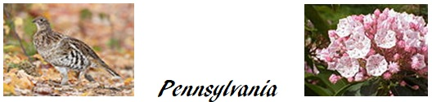

Bensalem Medical Center
Centre Plaza Shopping Center, Bensalem, PA 19020.

The closest CHC is almost 5 miles away, but over the border in New Jersey (Burlington City Health Center).

Possible affordable clinics nearby:

1.7 miles away – St. Mary Adult Health Center. 2546B Knights Road, Bensalem, PA 19020.

1.8 miles away – Holy Redeemer Women’s Care. 3300 Tillman Drive, Bensalem, PA 19020.

Congressional District #1. U.S. Representative Brain K. Fitzpatrick (R)

Bridgeville Health Center
533 Washington Pike, Suite 203, Bridgeville, PA 15017

The closest CHC is over just over 5 miles away (North Side Christian Health Center).

Congressional District #18. U.S. Representative: Mike Doyle (D)

Moon Township Health Center
935 Beaver Grade Road, Suite 12, Moon Township, PA 15108
,
The closest CHC is over 8 miles away (Sto-Rox Family Health Care in McKees Rocks).

A possible source of gynecological services nearby:

0.7 miles away – Premier Women’s Health-Edgetowne Commons, 1009 Beaver Grade Road, Suite 200, Moon Township, PA 15108.

Congressional District #17. U.S. Representative: Christopher Deluzio (D)

Warminster Medical Center
610 Louis Drive, Warminster, PA 18974

The closest CHC is over 9 miles away (Covenant House Wellness Clinic in Wyncote).

A possible affordable clinic nearby:

1.6 miles away – Abington Jefferson Health-Warminster, 225 Newtown Road, Warminster, PA 18974.

Warminster. Congressional District #1. U.S. Representative: Brian Fitzpatrick (R)

West Chester Health Center
8 S. Wayne Street, West Chester, PA 19382

The closest CHC is almost 10 miles away (La Comunidad Hispana in Kennet Square).

Possible sources of gynecological services nearby:

1.4 miles away – Penn Ob/Gyn Chester County West Chester, East Marshall Street Medical Building, Suite 205, 600 East Marshall Street, West Chester, PA 19380.

1.5 miles away – West Chester Ob/Gyn Clinic, Chester County Hospital, 701 East Marshall Street, Ground Floor, West Chester, PA 19380.
West Chester. Congressional District #6. U.S. Representative: Chrissy Houlahan (D)

